

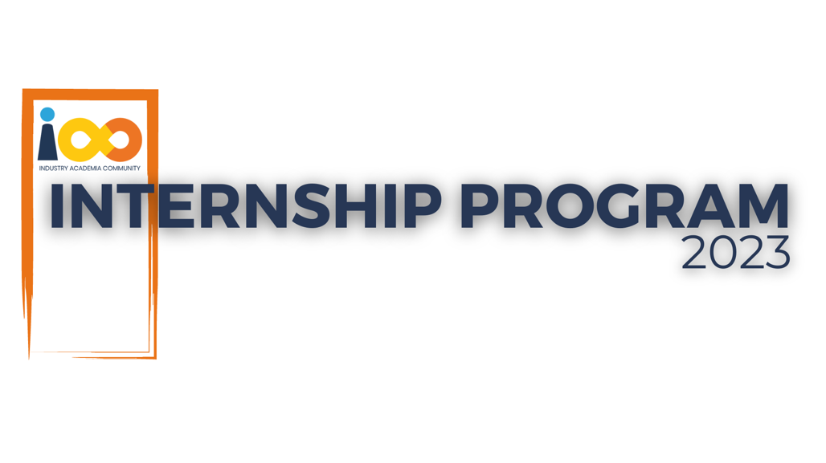

PROJECT REPORT

Data Analytics  
  
Absence of insights for the relationship between student's economic background, academic performance, competence and expected salary.

|  |  |  |  |
| --- | --- | --- | --- |
| **Created By:** | Pranav Patel | **Approved By:** | Suraj Mane |
| **Created On:** | 13-Jun-2025 | **Approved On:** | DD-MMM-YYYY |

Page left blank intentionally

**INDEX**

**1** **PROJECT DETAILS** 2

**2** **SUMMARY** 2

**3** **INTRODUCTION** 2

3.1 Background 2

3.2 Stakeholders 2

3.3 Objectives 2

**4** **METHODOLOGY** 3

4.1 Considerations & Assumption 3

4.2 Approach 3

4.3 Activities 4

**5** **TARGETTED V/S ACHIEVED OUTPUT** 5

**6** **CONCLUSION** 5

**General Instructions for using the Live Project Report Template**

* This template and the subsequent document created using this template is a confidential document and is the intellectual property of Cloud Counselage Pvt. Ltd. Circulating it outside of the organisation without the consent of Cloud Counselage Pvt. Ltd. is the breach of company policies and will lead to legal actions
* This template is a guideline document to communicate the implementation of design ideas and the results of the work to the stakeholders.
* The **text between inequality (< >) is to be replaced** by relevant text
* Please **remove the yellow highlight on the Text** between the inequality (< >). This is done to help you notice the text to be changed/replaced
* The text in *italics* highlighted in grey is just for reference and should be removed after adding the relevant text

# **PROJECT DETAILS**

|  |  |  |  |
| --- | --- | --- | --- |
| **Project Name** | Absence of insights for the relationship between student's economic background, academic performance, competence and expected salary. | | |
| **Project Sponsor** | Tushar Topale | | |
| **Project Manager** | Harshada Topale | | |
| **Start Date** | 09-Jun-2025 | **Completion Date** | 16-Jun-2025 |

# **SUMMARY**

The aim of the project was to deliver insights regarding various factors of a student such as economic background, expected salary and others to the stakeholders, as directed by the problem statement. This initiative was undertaken to ensure that relevant steps to improve students’ career readiness and employability are taken. The project aims to deliver knowledge or value into the students’ current career progression and allowing solutions to be developed to bridge the gap between academia and the industry.

# **INTRODUCTION**

## Background

Millions of students apply for internships or jobs every year with their resumes. Recruiters spend a very short span of time reviewing resumes and more than 70% of resumes get rejected in the initial screening stages. Understanding factors influencing students’ success, and the gap between education and industry needs. By way of this procedure, developing solutions to improve industry readiness and employability of students.

## Stakeholders

**Internal Stakeholders**

Project Sponsor - Tushar Topale

Project Manager - Harshada Topale

Domain Lead – Suraj Mane

**External Stakeholders –** Students

**End Customer** – Cloud Counselage Pvt Ltd.

## Objectives

Objectives under consideration- Conducting comprehensive analysis of student responses to gains insights as per the problem statement.

Objectives achieved – Analysis of student responses as per the problem statement and deliverance of insights and project documentation.

Changes to Project Charter – Milestones achieved earlier than expected dates, resulting in earlier completion of the project.

# **METHODOLOGY**

## Considerations & Assumption

* Assumptions - The data is accurate and representative of the most recent student demographics. Additional external sources of data are not required for attaining the project objective.
* Challenges -
  1. Data Cleaning – Duplicate values in the table. Solved by removing duplicates by the Email IDs.
  2. Data Transformation – Presence of multiple values for the column “How did you come to know about this event”. Solved by taking the 1st value.
* Constraints – Working with a single dataset that may limit analysis to just student responses.

## Approach

Domain Meeting and Requirement Elicitation Meeting – Understanding the system requirements and problem statement objectives to be achieved, dictating the workflow.

Workflow -

1. Data Investigation – Understanding what the data is about. Identifying the different fields in the data and how they may deliver insights. Spotting any irregularities in the data or ambiguity in problem statement.

2. Cleaning – Removing any irregularities in the data, resulting in accurate insights.

Steps taken:

* Capitalizing college name, and converting student name and city to proper case.
* Removed duplicates based on the email ID
* Regularized Leadership skills column values.
* Rounded off CGPAs, among others.

3. Transformation – Creating additional columns or any transformations needed to achieve project objectives.

Steps taken:

* Selecting the 1st value in the Promotion Channel related column and replacing “Others” with value in the adjoining column.
* Creating a new column to group events by their topic.
* Selecting the top value from Family Income column as the final value.
* Creating another table with splitted values into rows of Promotion Channel column, allowing all the multivariate records to be used, as an alternate approach.

4. Analysis, Visualizations and Insights – Analysis as per the problem statement, identification of correlations and patterns and other additional insights, delivered via a report in Power BI.

## Activities

Prerequisites –

* Pre internship sessions.
* Industry Trainings
* Live Project Introduction and adjoining activities

1. Project Initiation
   * + Project Charter – Outlining scope of the project, deliverables, people, milestones, budget, risks and additional details.
     + Requirement Gathering – Elicitation Meeting and Problem Statement. Understanding client and system requirements
     + SRS – Describing the system to be designed.
2. Project Planning
   * WBS - Dividing project into actionable tasks
   * Project Schedule - Course of activities for the project
   * RAID Logs – Tracking risks, assumptions, issues and dependencies throughout the lifecycle of the project.
   * Lessons Learnt – Detailing lessons observed during various phases of the project.
3. Execution
   * Data Analysis – Conducting the analysis as per problem statement and workflow presented above.
4. Closure
   * Project Report – Communicating the implementation of design ideas and the results of the work to the stakeholders.
   * Submitting deliverables.

# **TARGETED V/S ACHIEVED OUTPUT**

Targeted output - Dashboard or insights developed in tool of choice, video explanation and adjoining documentation delivering decision making capability to stakeholders.

Expected completion date - 09-07-2025

Achieved Output – Report developed in Power BI, video explanation and adjoining documentation delivering decision making capability to stakeholders.

Additional insights also crafted.

Actual completed date - 16-06-2025

# **CONCLUSION**

**Benefits** – Understanding the gaps in students’ success, and delivering specific solutions, such as:

* Engaging with other colleges in the areas with observed higher student engagement such as Maharashtra and Rajasthan.
* Creating workshops and sessions to guide students in improving their programming expertise.
* Delivering more sessions on the topics that have a higher student attendance like CV & Skill Building.
* Reducing efforts in underperforming promotion channels and pushing forth others with better engagement.
* Crafting sessions to understand reasons behind high salary expectation among the students and other ambiguity about careers among students.

**Future Scope -**

A. Involving future Data Analyst Interns in crafting a survey, for the students who have completed the esteemed Cloud Counselage internship and are currently industry professionals. This will allow the interns to get a sense of data gathering.

B. Involving the above survey data, with corresponding respondent student records and other adjoining data, allowing interns to experience how data can be merged from different datasets.

C. Deriving insights from the A & B, as to how this internship has been beneficial for the past interns, are they in a career field separate from their internship domain, any industry trends spotted, and any others.

D. Using these observations, insights and data, to enhance the internship experience, problem statement and other deliverables for future interns.